CONGRATULATIONS FOR EXEMPLARY ACADEMIC PERFORMANCE

COORG PUBLIC SCHOOL & PRE-UNIVERSITY COLLEGE (COPS)
GONIKOPPAL, SOUTH KODAGU, KARNATAKA.
Ph: 08274 - 247011/247881, E-mail: copsgonikoppal@gmail.com Website: www.coorgpublicschool.org.in

ICSE (X) 2018-19
100% Results (for 21 Successive Years)

6 students have achieved the unique distinction of scoring one point in all the subjects, thereby securing Top One Tenth Position at the ALL INDIA LEVEL

ICSE (X) – 2019
Appeared – 78
Above 90% – 27
Between 80 & 89% – 26
Between 70 & 79% – 16
Between 64 & 69% – 09

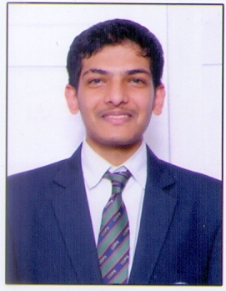
Mst. A B Devaiah
97%

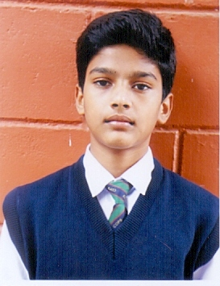
Mst. Varun S
96%

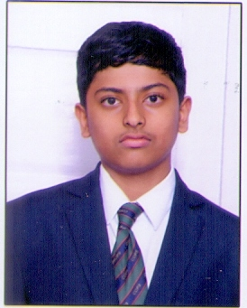
Mst. Karan Sathish
96%

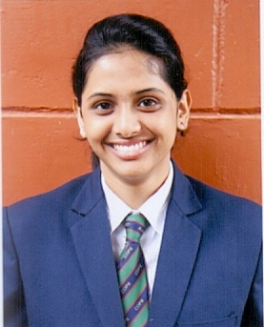
Ms.P G Lisha
96%

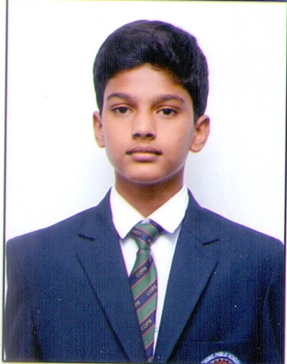
Mst. Varun S
96.60%

Ms.P G Lisha
96.40%

Mst. Karan Sathish
96.80%

Mst. A B Devaiah
98.20%

ICSE (X) – 2019
Appeared – 78
Distinction – 62
First Class - 16

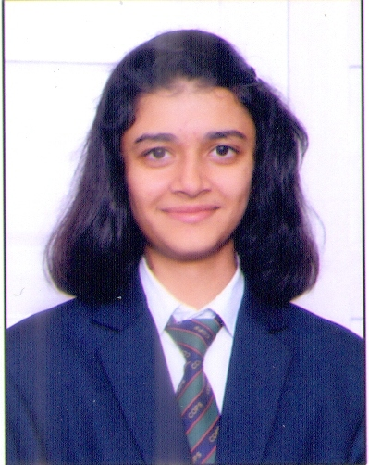
Ms. Akshatha Kariappa
95%

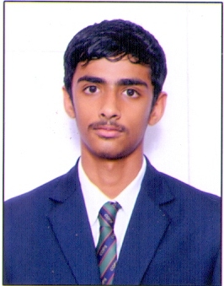
Mst.P U Pratham Karumbaiah
95.20%

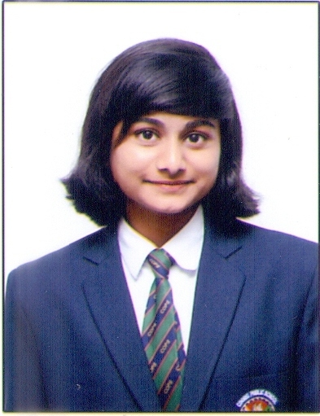
Ms.Raveena Sanjeev Karvekar
95.40%

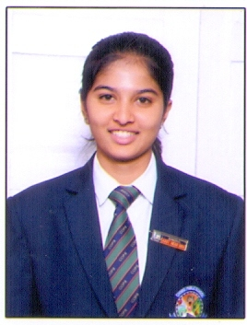
Ms. Tamanna Appachu K
96%

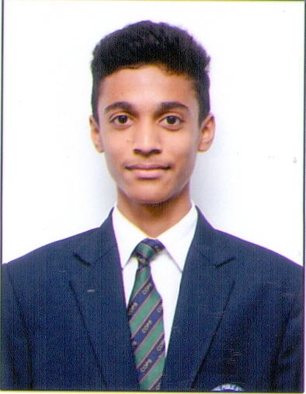

Mst. Aditya Gowda
V N
95%

Mst. K Anurag Nandish
95%

Six students have achieved the unique distinction of scoring one point in all the subjects, thereby securing Top One Tenth Position at the ALL INDIA LEVEL

Students scoring 100 in various subjects
English Paper 2 – 02
History & Civics – 12
Geography – 03
Chemistry – 01
Computers – 01
Biology – 01
Physical Education - 05

II PUC - 2018 – 19

Commerce Science II PUC 2019

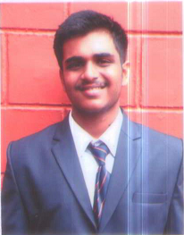

Mst. B R Sharan – 94%
PCMC – 96%
College Topper in Science

Appeared - 63

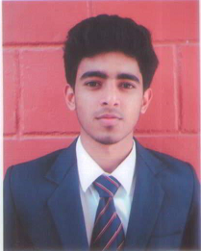
Mst. B M Tarun Thimmaiah – 95%
EBAC – 98%
College Topper in Commerce

Distinction - 19
First Class - 36
Second Class - 03
Pass - 01

Mst. B R Sharan - 100 in Computer Science
Mst. B M Tarun Thimmaiah - 100 in Business Studies & Computer Science
Mst. Joe Mathew - 100 in Computer Science
Mst. P Rohan Belliappa - 100 in Computer Science
Mst. C A Aiyappa - 100 in Computer Science

Kodagu Academy for Education and Culture

Mr. M M Thimmaiah Mr. M N Belliappa Mr. K.A.Poonacha Mr. K.A. Subbaiah Prof. M.D.Nanjunda
President Vice President Secretary Treasurer Joint Secretary

